**TOPOLOGY SELECTION**

The Project includes 2 basic problems. One of them is the AC to DC conversion and other one is speed control of DC motor. AC to DC conversion is made by using rectifier circuits such as thyristor and diode rectifier. In addition, speed is directly controlled by input voltages or it is controlled by using PWM control (Appendix). Also, the DC motor can be connected as series, shunt or separately excited. The connection method changes the characteristic of the motor and controlling systems.

For our topology, DC motor is excited by separately and the AC to DC conversion are made by diode rectifier. In addition, the motor is controlled by PWM control.

**AC to DC Conversion**

AC to DC conversion are made by using rectifier circuit. There are some rectifier topologies such as diode and thyristor rectifiers. Diode rectifiers are used for uncontrolled rectification. Thus, the output voltage is not controlled externally. Thyristor rectifiers are controlled by firing angle and output voltage level can be adjusted. In our cases, we wanted that rectifier gives the uncontrolled, constant DC voltage. Hence, a diode rectifier circuits were used at this project.

In addition, it is supposed that output of rectifier circuit has low voltage ripple. Thus, the 3 phase diode rectifiers were used. The three-phase diode bridge with DC link capacitor are illustrated at Figure X. The DC link capacitor is used for minimizing voltage ripple at output of the rectifier.

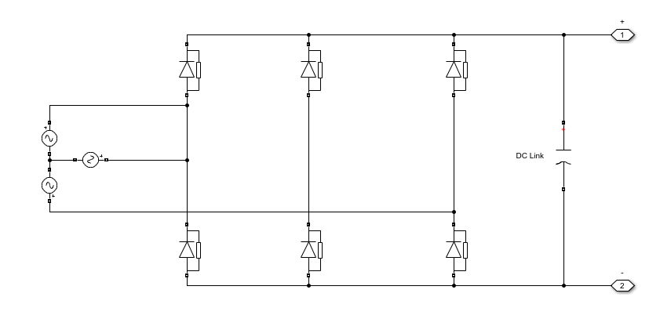

For the Figure X, the output voltage is $1.35Vll$ ( Line-to-Line Voltage) and the ripple without capacitor is 300 Hz. The capacitor is used for destroying this voltage ripple. The capacitor is range of hundred micro farad and it is called DC link capacitor.

**SPEED CONTROL**

At AC to DC conversion, 3 phase diode rectifiers were used and the output of the rectifier were constant. The speed of the motor can be controlled by voltage level changing at armature terminal of the motor. Thus, the voltage level is adjusted by using PWM control. Physical meaning of the PWM is switching device that led the current flow at specific time in periodic way. The switching device is called as transistor. When the transistor is off, the other switch led load current flow over. The other switch is diode that is called Free-Wheeling Diode. It is obligatory because of the motor; inductive load and it does not lead the current change immediately. The switching transistor and free-wheeling diode are illustrated at figure X.

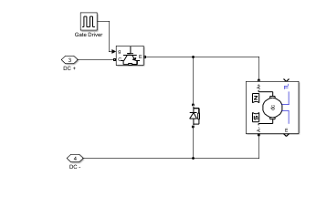

Duty level determines the armature voltage of the Dc motor and it adjust the speed and torque of the DC motor.

$Armature Voltage= DVin$

Also, the transistor is controlled by the gate driver. The gate driver switches the transistor and it controls the duty cycle and so armature voltage.

For controlling the duty, the controller must be used. The controller can be analog or digital. Also, the controller signal is isolated with transistors due to avoiding the ground loop.

**OVERALL DESİGN**

The overall design is merged form of two parts. One of them AC to DC converter, and other one is voltage level regulator. The Figure XX is illustrated the overall circuit schematic. Gate Driver has two basic unit which are controller and electrical isolator.

